Comparative Neuroanatomy of the Rat and Fish Brain

Introduction

Why Comparative Neuroanatomy is Important
Comparative neuroanatomy is the study of similarities and differences in the nervous systems of different animal species. By comparing brain structures across vertebrates, scientists can understand how the brain has evolved to support increasingly complex behaviors, cognition, and environmental adaptations. Studying different species helps identify brain regions that are conserved throughout evolution as well as those that have become specialized for specific functions. This knowledge provides valuable insights into normal brain organization, neural development, and the mechanisms underlying neurological disorders.

Evolution of Vertebrate Brains
The vertebrate brain has undergone significant evolutionary changes over millions of years. Early vertebrates, such as fish, possess relatively simple brains that are highly adapted for essential survival behaviors including swimming, feeding, predator avoidance, and sensory processing. In fish, the optic tectum is particularly well developed because vision is crucial for navigation and prey detection.
As vertebrates evolved into amphibians, reptiles, birds, and mammals, the forebrain expanded considerably. Mammals, including rats, developed a large cerebral cortex and hippocampus, enabling advanced learning, memory, decision-making, and social behaviors. Despite these differences, all vertebrate brains share a common developmental organization consisting of the forebrain, midbrain, and hindbrain, reflecting their shared evolutionary ancestry.

Why Rats and Fish are Commonly Used Animal Models in Neuroscience
Both rats and fish are widely used experimental models because they provide complementary insights into nervous system structure and function.
Rats are among the most extensively studied mammalian models due to their close anatomical, physiological, and behavioral similarities to humans. Their well-developed cerebral cortex and hippocampus make them excellent models for investigating learning, memory, emotion, neurodegenerative diseases, stroke, addiction, and brain injury. Rats are also capable of performing complex behavioral tasks such as maze learning, making them ideal for studying cognitive functions.
Fish, particularly species such as Zebrafish, offer unique advantages including rapid development, high reproductive rates, transparent embryos, and remarkable regenerative abilities. Unlike mammals, zebrafish can regenerate damaged brain tissue, making them valuable for studying neural regeneration, developmental neuroscience, genetics, and disease mechanisms. Their genetic similarity to humans also allows researchers to investigate the molecular basis of many neurological disorders.Together, rat and fish models provide complementary perspectives on vertebrate brain organization, function, and evolution.

Applications in Biomedical Research
Comparative studies of rat and fish brains have contributed significantly to advances in biomedical science. Rat models are extensively used to investigate neurological disorders such as Alzheimer's disease, Parkinson's disease, Stroke, epilepsy, traumatic brain injury, anxiety, depression, and addiction. They are also widely used for testing new drugs before clinical trials.
Fish models, especially zebrafish, have become important in developmental biology, genetics, neurotoxicity testing, regenerative medicine, and high-throughput drug screening. Their ability to regenerate neurons offers promising opportunities for discovering therapies aimed at repairing damaged nervous tissue in humans.
By integrating findings from both mammalian and non-mammalian models, researchers gain a more comprehensive understanding of brain function, disease mechanisms, and potential therapeutic strategies. Comparative neuroanatomy therefore serves as a crucial bridge between basic neuroscience research and clinical medicine.

Objectives
The primary objective of this project is to compare the gross anatomy of the rat and fish brain and understand how structural differences are related to their functions, behavior, and evolutionary adaptations. Specific objectives include:
- Compare the gross anatomy of rat and fish brains
  - Examine the external morphology of both brains.
  - Identify similarities and differences in overall size, shape, and organization.
- Identify major brain regions
  - Recognize important anatomical structures such as the olfactory bulbs, cerebrum (telencephalon), optic tectum, cerebellum, medulla oblongata, and spinal cord.
  - Describe the location and basic function of each brain region.
- Understand functional adaptations
  - Explain how differences in brain anatomy reflect each animal's lifestyle and ecological needs.
  - Relate specialized structures to sensory processing, locomotion, learning, memory, and motor coordination.
- Relate anatomical differences to behavior and evolution
  - Compare the behavioral capabilities of rats and fish based on their brain organization.
  - Discuss how vertebrate brains have evolved from simpler to more complex forms while retaining common structural features.
- Understand the importance of animal models in neuroscience
  - Explain why rats are widely used to study mammalian brain function and neurological diseases.
  - Describe the advantages of fish models, particularly Zebrafish, for developmental biology, genetics, and regenerative neuroscience.

6.Explore biomedical research applications
- Demonstrate how comparative neuroanatomy contributes to understanding human neurological disorders, drug discovery, and translational neuroscience.

4. Materials and Methods

Materials
The following materials were used for the comparative anatomical study of the rat and fish brains:
- Preserved rat brain specimen
- Preserved fish brain specimen
- Standard dissection kit (scalpel, scissors, forceps, and dissecting needles)
- Dissection tray
- Gloves and laboratory safety equipment
- Digital camera/mobile phone camera for documentation
- Laboratory manual and neuroanatomy reference atlas for identification of brain structures
- Labels and notebook for recording observations

Methods
The comparative study was carried out during postgraduate zoology laboratory sessions. Preserved specimens of the rat and fish were carefully examined to identify the major external brain structures.
Using standard dissection instruments, the cranial cavity was exposed to reveal the brain while minimizing damage to the surrounding tissues. The specimens were observed from dorsal and lateral aspects, and prominent anatomical regions were identified with the help of laboratory manuals and standard neuroanatomy atlases.
The following structures were identified and compared between the two species:
- Olfactory bulbs
- Cerebrum (Telencephalon)
- Midbrain (Optic tectum)
- Cerebellum
- Medulla oblongata
- Spinal cord
Photographs of the specimens were taken during the practical session to aid in documentation and comparison. The observed anatomical features were recorded and later compared based on their morphology, relative size, position, and known physiological functions.

Observation Method
Observations were performed through direct visual examination of both specimens. Each brain region was identified according to its anatomical position and external characteristics. Comparative observations focused on:
- Overall brain morphology
- Relative size of different brain regions
- Structural organization
- Functional significance of each region
- Similarities and differences between rat and fish brains
The findings were interpreted using established principles of comparative vertebrate neuroanatomy and correlated with the behavioral and ecological adaptations of each species.

Practical Experience
As part of my Master's practical coursework in Zoology, I participated in the dissection and examination of both rat and fish brains. During these laboratory sessions, I identified major neuroanatomical structures, compared their organization, and documented the observations. This practical experience strengthened my understanding of vertebrate brain anatomy, functional specialization, and evolutionary adaptations, providing a foundation for this comparative neuroanatomical study.
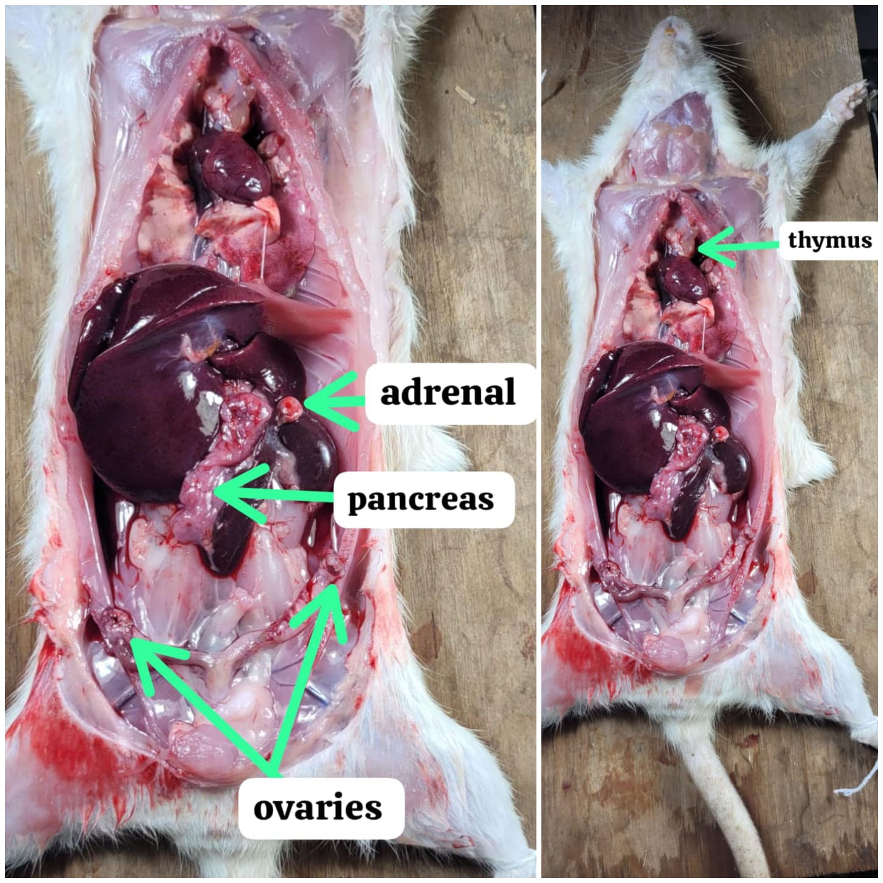

5. Healthy Rat Brain Anatomy
The rat brain is a highly organized central nervous system that shares many anatomical and functional similarities with the human brain. Although smaller in size, it contains the same major brain regions responsible for sensory processing, movement, learning, memory, emotion, and homeostatic regulation. These similarities make rats one of the most widely used mammalian models in neuroscience research.

1. Olfactory Bulb
The olfactory bulb is located at the anterior end of the brain and is the first structure involved in processing smell. It receives sensory information from olfactory receptor neurons in the nasal cavity and transmits it to higher brain centers. In rats, this structure is relatively large because they rely heavily on their sense of smell for locating food, recognizing mates, and detecting predators.

2. Cerebral Cortex
The cerebral cortex is the outer layer of the cerebrum composed of gray matter. It is responsible for higher cognitive functions including sensory perception, voluntary movement, learning, memory, and decision-making. Although less folded than the human cortex, the rat cerebral cortex is highly developed and plays a central role in behavioral and experimental neuroscience.

3. Corpus Callosum
The corpus callosum is a thick bundle of nerve fibers connecting the left and right cerebral hemispheres. It enables communication between both sides of the brain, allowing integration of sensory, motor, and cognitive information. Efficient interhemispheric communication is essential for coordinated movement and complex behaviors.

4. Hippocampus
The hippocampus is located within the temporal region of the forebrain and is a key component of the limbic system. It plays a vital role in learning, spatial navigation, and the formation of long-term memories. Because hippocampal degeneration occurs early in Alzheimer's disease, this region is extensively studied in neuroscience research.

5. Thalamus
The thalamus is situated near the center of the brain and serves as the major relay station for sensory information. Nearly all sensory signals, except olfactory input, pass through the thalamus before reaching the cerebral cortex. It also contributes to motor coordination, consciousness, attention, and sleep regulation.

6. Hypothalamus
Located beneath the thalamus, the hypothalamus is a small but essential brain region responsible for maintaining homeostasis. It regulates body temperature, hunger, thirst, circadian rhythms, hormonal secretion through the pituitary gland, and autonomic nervous system functions. It also plays an important role in emotional and stress responses.

7. Midbrain
The midbrain lies between the forebrain and hindbrain and forms part of the brainstem. It contains structures involved in visual and auditory reflexes, motor control, and eye movements. The midbrain also contains dopamine-producing neurons, making it particularly important in studies of Parkinson's disease.

8. Cerebellum
The cerebellum is located posterior to the cerebrum and has a highly folded surface that increases its neuronal density. It coordinates voluntary movement, balance, posture, muscle tone, and motor learning. Damage to the cerebellum results in impaired coordination, tremors, and difficulties maintaining balance.

9. Medulla Oblongata
The medulla oblongata is the lowest portion of the brainstem and connects the brain with the spinal cord. It contains vital autonomic centers that regulate breathing, heart rate, blood pressure, swallowing, and other involuntary functions essential for survival. It also serves as a pathway for ascending and descending nerve tracts.

10. Spinal Cord
The spinal cord extends caudally from the medulla oblongata through the vertebral column. It transmits sensory information from the body to the brain and motor commands from the brain to muscles. In addition, it contains neural circuits responsible for rapid spinal reflexes that occur without direct involvement of higher brain centers.
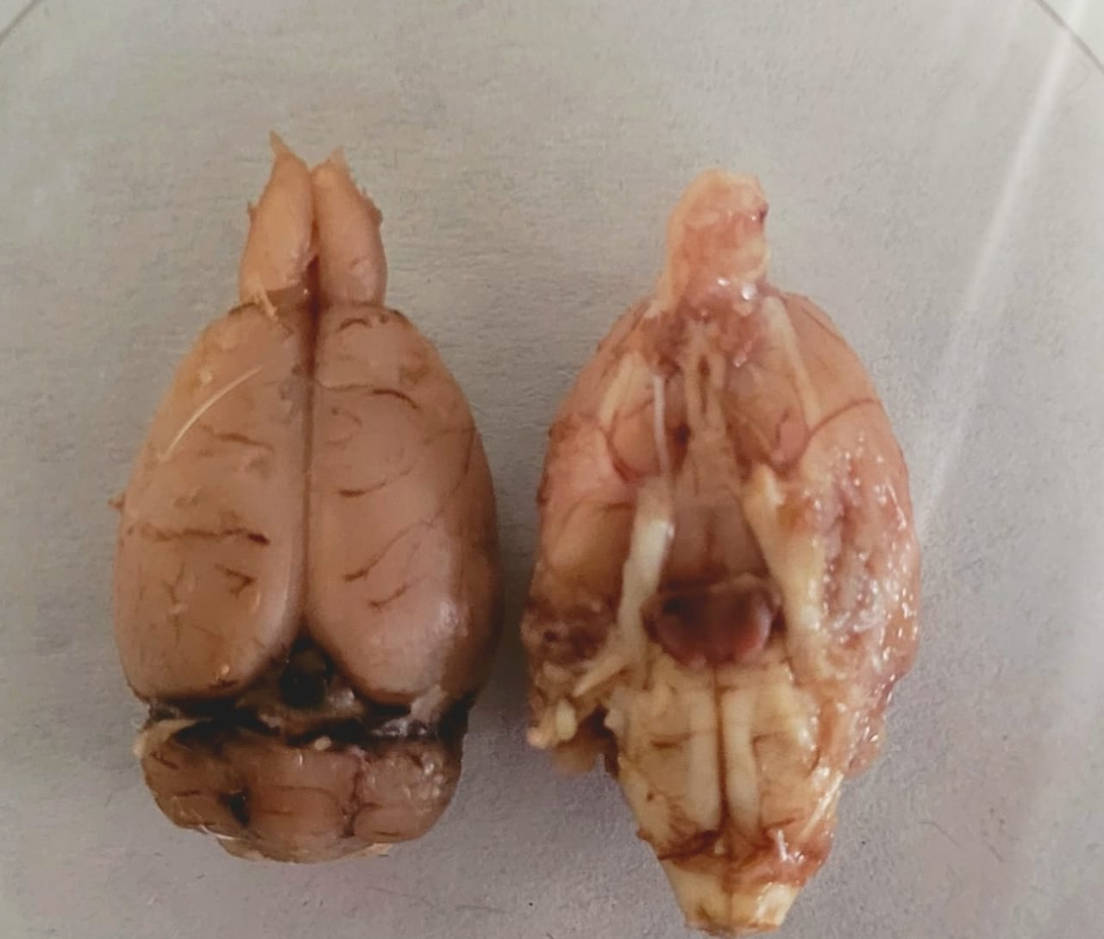

Summary Table
Brain Region | Primary Function
Olfactory bulb | Detection and processing of smell
Cerebral cortex | Cognition, perception, learning, voluntary movement
Corpus callosum | Communication between cerebral hemispheres
Hippocampus | Learning, spatial navigation, memory formation
Thalamus | Relay of sensory and motor information
Hypothalamus | Homeostasis, endocrine regulation, autonomic control
Midbrain | Visual and auditory reflexes, motor control
Cerebellum | Balance, posture, coordination, motor learning
Medulla oblongata | Control of vital autonomic functions
Spinal cord | Signal transmission and spinal reflexes

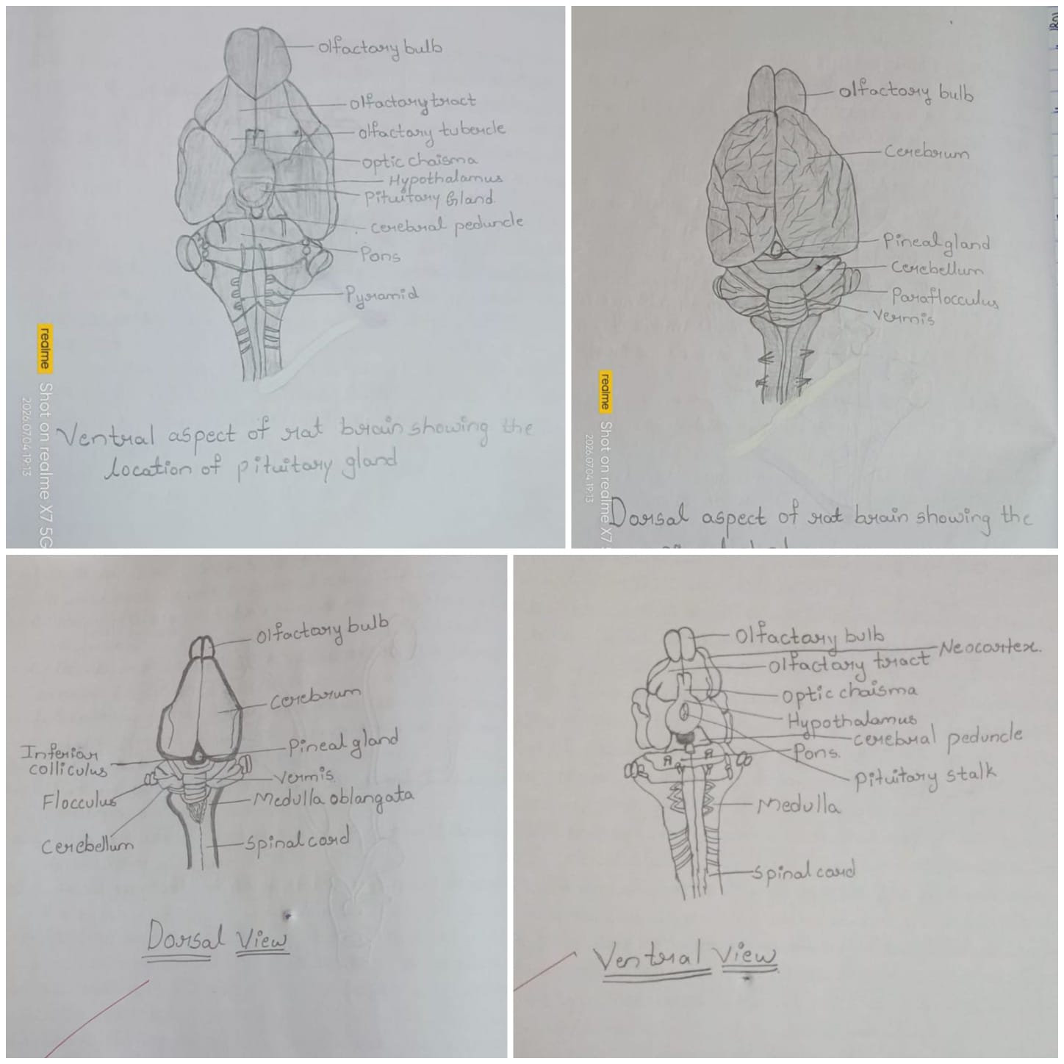

6. Healthy Fish Brain Anatomy
The fish brain is the central organ of the nervous system and is organized into the forebrain, midbrain, and hindbrain. Although smaller and less complex than the mammalian brain, it contains all the major regions required for sensory perception, movement, homeostasis, and survival. Fish brains are highly adapted to aquatic environments, with particularly well-developed visual and motor control centers.

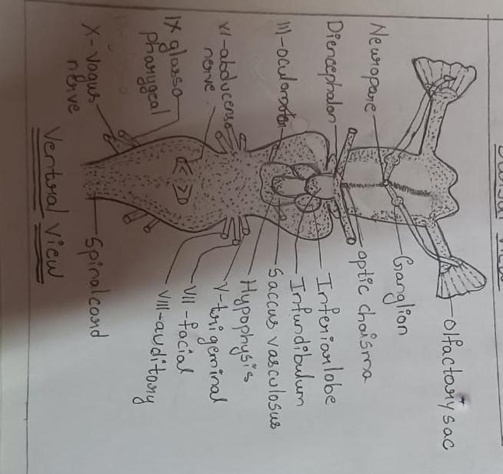

1. Olfactory Bulb
The olfactory bulbs are located at the anterior end of the brain and receive sensory information from olfactory receptors in the nasal cavity. They are responsible for detecting chemical signals in water, allowing fish to locate food, recognize mates, avoid predators, and navigate their environment. In many fish species, the olfactory bulbs are relatively large because the sense of smell is essential for survival.

2. Telencephalon
The telencephalon forms the major part of the forebrain and is involved in learning, memory, spatial orientation, and behavioral responses. Although less developed than the mammalian cerebral cortex, it integrates sensory information and contributes to decision-making and social behaviors. The telencephalon also participates in olfactory processing.

3. Optic Tectum
The optic tectum is the largest and most prominent structure of the fish midbrain. It receives visual information directly from the retina and processes visual stimuli such as movement, prey detection, and obstacle avoidance. Because vision is vital for many fish species, the optic tectum is proportionally much larger than in mammals.

4. Cerebellum
The cerebellum is located behind the optic tectum and is responsible for coordinating muscle activity, balance, posture, and swimming movements. It integrates sensory input with motor commands to produce smooth and precise locomotion. Active swimmers generally possess a larger and more developed cerebellum.

5. Medulla Oblongata
The medulla oblongata is situated in the hindbrain and connects the brain to the spinal cord. It regulates essential autonomic functions including respiration, heart rate, blood circulation, and gill movements. The medulla also serves as a relay center for sensory and motor pathways.

6. Pituitary Gland
The pituitary gland is a small endocrine organ located beneath the forebrain and connected to the hypothalamus. It secretes hormones that regulate growth, reproduction, metabolism, osmoregulation, and stress responses. The pituitary plays a central role in maintaining physiological balance and coordinating endocrine functions.

7. Pineal Gland
The pineal gland is located on the dorsal surface of the brain and functions as a photoreceptive endocrine organ. It produces the hormone melatonin, which regulates circadian rhythms, seasonal breeding cycles, and responses to changes in light intensity. In many fish species, the pineal gland is directly sensitive to environmental light.

8. Cranial Nerves
Fish possess multiple pairs of cranial nerves that originate from the brain and innervate the head and sensory organs. These nerves control vision, smell, hearing, taste, balance, feeding, and movement of the jaws and gills. Cranial nerves are essential for coordinating sensory perception and motor functions in the aquatic environment.

Summary Table
Brain Region | Primary Function
Olfactory bulb | Detects chemical signals and processes smell
Telencephalon | Learning, memory, behavior, and olfactory integration
Optic tectum | Visual processing, prey detection, and orientation
Cerebellum | Balance, posture, swimming coordination, and motor control
Medulla oblongata | Controls respiration, circulation, and autonomic functions
Pituitary gland | Hormone secretion and endocrine regulation
Pineal gland | Melatonin production and circadian rhythm regulation
Cranial nerves | Sensory perception and motor control of the head and gills

Key Features of the Fish Brain
- Simpler overall organization than the rat brain but contains the same major divisions: forebrain, midbrain, and hindbrain.
- The optic tectum is proportionally much larger than in mammals, reflecting the importance of vision in aquatic environments.
- The telencephalon is less developed than the mammalian cerebrum, resulting in simpler cognitive processing.
- The cerebellum is well developed to coordinate precise swimming movements and maintain balance.
- The pineal gland has an important role in detecting environmental light and regulating biological rhythms.
- Many fish species, especially Zebrafish, are widely used in neuroscience because of their transparent embryos, rapid development, and remarkable ability to regenerate nervous tissue.
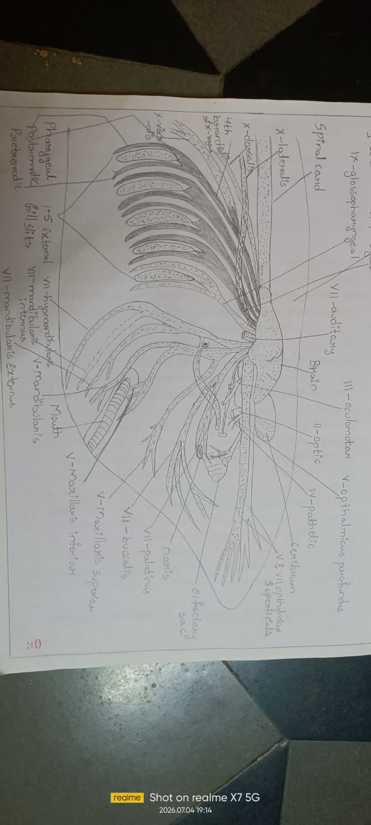
Feature | Rat | Fish
Brain size | Larger | Smaller
Cerebral cortex | Highly developed | Poorly developed
Optic tectum | Moderate | Very large
Cerebellum | Large | Large in active swimmers
Olfactory bulb | Large | Species dependent
Learning ability | High | Moderate
Memory | Complex | Simpler
Vision | Cortex involvement | Optic tectum dominant
Hearing | Advanced | Simpler
Behavior | Complex | Mostly instinctive

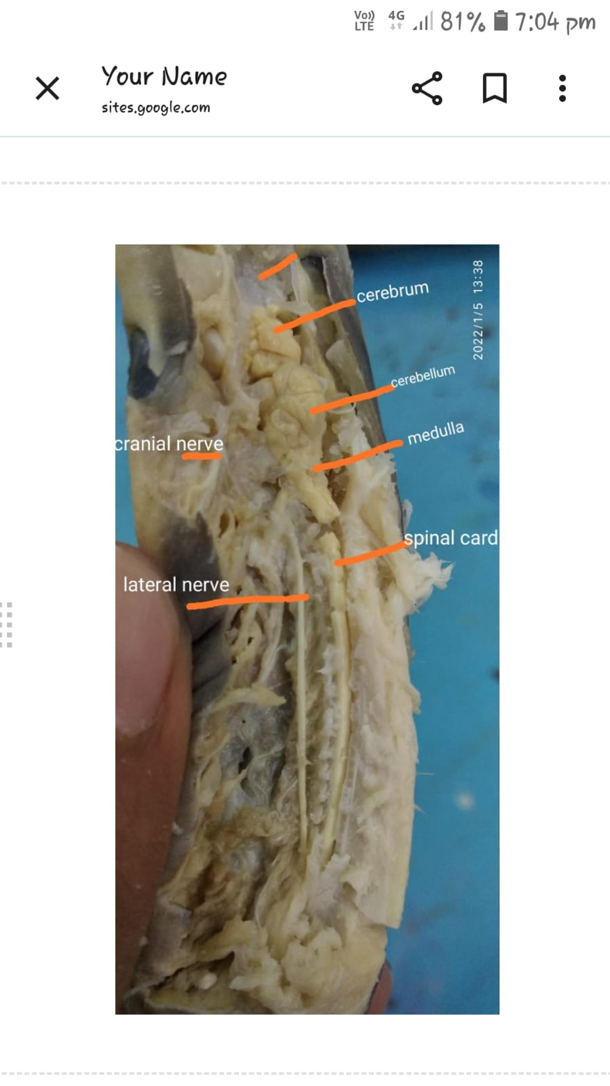

7. Functional Comparison of the Rat and Fish Brain
Although rats and fish share the same basic vertebrate brain organization, the relative size and specialization of different brain regions reflect their unique lifestyles and environmental adaptations. Mammalian brains have evolved to support higher cognitive abilities and complex social behaviors, whereas fish brains are optimized for rapid sensory processing, swimming, and survival in aquatic habitats.

1. Learning
Rats possess a highly developed cerebral cortex and hippocampus that enable advanced learning, problem-solving, and behavioral flexibility. They can learn complex tasks, navigate mazes, and adapt their behavior through experience.
Fish also demonstrate learning abilities, including associative and spatial learning. However, their simpler telencephalon supports less complex cognitive processing compared with mammals.

2. Memory
The hippocampus in rats is specialized for the formation of long-term memories and spatial navigation. It allows rats to remember routes, recognize environments, and learn from previous experiences.
Fish rely primarily on the telencephalon for memory formation. Although capable of remembering feeding locations and environmental cues, their memory systems are generally less sophisticated than those of mammals.

3. Vision
Vision is one of the most important senses in fish. Their large optic tectum processes visual information rapidly, enabling prey detection, predator avoidance, and navigation in aquatic environments.
In rats, visual information is processed mainly by the visual cortex after relay through the thalamus. Although rats possess functional vision, they depend more heavily on smell and touch than on sight.

4. Smell
The olfactory bulbs of rats are highly developed, making smell their dominant sensory modality. Rats use olfaction to locate food, identify other individuals, detect danger, and communicate through pheromones.Fish also possess well-developed olfactory bulbs that detect dissolved chemical substances in water. Olfaction helps them locate food, recognize mates, identify territories, and avoid predators.

5. Balance
The rat cerebellum coordinates posture, balance, and smooth voluntary movements during walking, climbing, and exploration.
In fish, the cerebellum is particularly important for maintaining body orientation and coordinating continuous swimming movements. Active swimmers generally have a relatively larger cerebellum.

6. Motor Control
Motor control in rats involves coordinated activity between the cerebral cortex, basal ganglia, cerebellum, brainstem, and spinal cord. These structures enable precise limb movements, grasping, and complex locomotion.
Fish rely primarily on the cerebellum, brainstem, and spinal cord to coordinate swimming, turning, feeding, and escape responses. Their movements are highly efficient and adapted to aquatic locomotion.

7. Social Behavior
Rats exhibit complex social behaviors including communication, cooperation, maternal care, territorial interactions, and social learning. These behaviors depend on the cerebral cortex, limbic system, and hypothalamus.
Fish display simpler forms of social behavior such as schooling, territorial defense, courtship, and reproductive interactions. Their behavior is largely driven by instinct, although some species can learn from experience.

8. Predator Avoidance
Rats avoid predators using a combination of smell, hearing, touch, vision, and memory. They can recognize dangerous environments and modify their behavior based on previous experiences.
Fish primarily depend on rapid visual processing by the optic tectum, detection of water vibrations through the lateral line system, and fast swimming coordinated by the cerebellum and spinal cord to escape predators.

Functional Comparison Table
Function | Rat | Fish
Learning | Advanced learning through cerebral cortex and hippocampus | Moderate learning through the telencephalon
Memory | Strong long-term and spatial memory | Simpler memory for environmental cues and feeding locations
Vision | Processed mainly by the visual cortex | Dominated by the large optic tectum
Smell | Highly developed; essential for survival and communication | Detects dissolved chemicals for food, mates, and predators
Balance | Controlled by the cerebellum during terrestrial movement | Controlled by the cerebellum for swimming and body orientation
Motor Control | Precise limb movements and coordinated locomotion | Efficient swimming coordinated by the cerebellum and brainstem
Social Behavior | Complex social interactions and communication | Simpler schooling, territorial, and reproductive behaviors
Predator Avoidance | Uses memory, smell, hearing, and vision | Relies on rapid vision, lateral line sensing, and escape swimming

Conclusion
The functional differences between rat and fish brains reflect their evolutionary adaptations to different environments. Rats possess enlarged forebrain structures that support higher cognition, learning, memory, and complex social behavior. In contrast, fish have specialized midbrain and hindbrain regions that optimize vision, swimming, and rapid responses to environmental challenges. Despite these differences, both species share the fundamental vertebrate brain plan, making them valuable models for studying nervous system function and evolution.

9. Evolutionary Perspective
The vertebrate brain has undergone remarkable evolutionary changes over the past 500 million years. Although fish and mammals possess the same basic brain plan—consisting of the forebrain, midbrain, and hindbrain—the relative size, complexity, and function of these regions have changed significantly. Comparing the brains of fish and rats demonstrates how evolution has shaped the nervous system to support increasingly complex behaviors, cognition, and environmental adaptations.

Evolution from Fish to Mammals
Fish represent some of the earliest vertebrates and possess a relatively simple but highly efficient brain adapted for aquatic life. Their nervous system is specialized for essential functions such as swimming, vision, feeding, predator avoidance, and environmental sensing.
As vertebrates evolved through amphibians, reptiles, birds, and finally mammals, the forebrain gradually increased in size and complexity. Mammalian brains, including those of rats, developed specialized regions responsible for advanced learning, memory, emotional regulation, and decision-making. Despite these changes, the overall organization of the vertebrate brain has remained conserved throughout evolution.

Enlargement of the Forebrain
One of the most significant evolutionary changes is the expansion of the forebrain (prosencephalon). In fish, the forebrain is relatively small and mainly involved in olfactory processing, basic learning, and instinctive behaviors.
In mammals, the forebrain became the dominant part of the brain. Enlargement of the cerebrum provided greater capacity for sensory integration, voluntary movement, planning, emotional processing, and higher-order cognitive functions. This expansion enabled mammals to adapt to more complex terrestrial environments and social interactions.

Development of the Cerebral Cortex
The cerebral cortex represents one of the defining characteristics of mammalian evolution. Fish do not possess a layered cerebral cortex comparable to that of mammals; instead, many forebrain functions are performed by the simpler telencephalon.
In mammals such as rats, the cerebral cortex evolved into a highly organized six-layered structure that processes sensory information, controls voluntary movement, supports language-related functions (in humans), and enables learning, reasoning, and memory. Increased cortical complexity has allowed mammals to develop sophisticated behaviors and greater behavioral flexibility.

Increased Cognitive Abilities
Evolution of the mammalian brain has been accompanied by significant improvements in cognitive function. Rats demonstrate advanced abilities such as spatial navigation, problem-solving, social learning, memory formation, and behavioral adaptation. These functions are supported primarily by the enlarged cerebral cortex, hippocampus, and limbic system.
Fish also exhibit learning, memory, and behavioral plasticity; however, these abilities are generally more limited and are closely linked to survival behaviors such as feeding, migration, predator avoidance, and reproduction. The differences in cognitive abilities reflect the progressive evolution of higher brain centers in mammals.

Importance in Vertebrate Evolution
Comparative studies of fish and mammalian brains provide valuable insights into the evolution of the vertebrate nervous system. Many brain structures—including the forebrain, midbrain, hindbrain, cranial nerves, and major neurotransmitter systems—have been conserved across vertebrate species, demonstrating a common evolutionary origin.
At the same time, evolutionary modifications such as forebrain enlargement, cortical development, and increased neural connectivity have enabled mammals to perform complex cognitive and behavioral tasks. Understanding these evolutionary changes helps researchers explain how the nervous system adapted to different ecological environments and provides a foundation for studying human brain development and neurological diseases.

Evolutionary Comparison Table
Evolutionary Feature | Fish | Rat (Mammal)
Forebrain | Relatively small | Highly enlarged and specialized
Cerebral Cortex | Absent as a layered neocortex; functions carried out by the telencephalon | Well-developed six-layered cerebral cortex
Dominant Brain Region | Optic tectum (vision) | Cerebral cortex (higher cognition)
Learning Ability | Basic to moderate | Advanced learning and problem-solving
Memory | Simple associative and spatial memory | Complex long-term and spatial memory
Social Behaviour | Mostly instinctive | Complex social interactions and communication
Environmental Adaptation | Aquatic life | Terrestrial life with diverse behavioral adaptations

Conclusion
The comparison of fish and rat brains illustrates the evolutionary transition from simpler vertebrate nervous systems to highly specialized mammalian brains. While fish possess neural structures optimized for survival in aquatic environments, mammals have evolved enlarged forebrains and sophisticated cerebral cortices that support advanced cognition, learning, memory, and social behavior. These evolutionary adaptations demonstrate how changes in brain structure have enabled vertebrates to occupy diverse ecological niches and respond to increasingly complex environmental challenges. This evolutionary continuity also makes comparative neuroanatomy an essential field for understanding brain function, development, and disease across species.

10. Applications in Neuroscience
Animal models are fundamental to neuroscience because they allow researchers to investigate brain structure, function, development, and disease under controlled experimental conditions. Rats and fish are among the most widely used vertebrate models, each offering unique advantages for studying neurological disorders, brain development, genetics, and potential therapeutic strategies. Their complementary characteristics have greatly advanced both basic and translational neuroscience research.

Rat Models in Neuroscience Research
Rats are one of the most extensively studied mammalian models because their brain organization, physiology, and behavior share many similarities with humans. Their well-developed cerebral cortex, hippocampus, and limbic system make them particularly valuable for investigating complex neurological functions and diseases.

1. Alzheimer's disease
Rat models are widely used to study the pathological mechanisms of Alzheimer's disease, including amyloid-beta plaque formation, tau protein abnormalities, neuroinflammation, and neuronal degeneration. They help researchers understand disease progression and evaluate new drugs aimed at improving memory and slowing neurodegeneration.

2. Parkinson's disease
Experimental rat models reproduce degeneration of dopamine-producing neurons in the substantia nigra, leading to motor impairments similar to Parkinson's disease. These models are used to investigate disease mechanisms, test neuroprotective therapies, and evaluate treatments such as dopamine replacement and deep brain stimulation.

3. Stroke
Rats are frequently used to study cerebral ischemia and hemorrhagic stroke. Researchers investigate neuronal injury, inflammation, blood flow changes, and functional recovery while developing therapies that may reduce brain damage and improve rehabilitation outcomes.

4. Learning and Memory
Because rats possess a highly developed hippocampus and cerebral cortex, they are ideal for studying learning and memory. Behavioral tests such as the T-maze, Y-maze, radial arm maze, and Morris water maze are commonly used to investigate spatial learning, memory formation, and cognitive flexibility.

5. Drug Testing
Before new neurological drugs enter clinical trials, they are often evaluated in rat models for safety, pharmacokinetics, efficacy, and potential side effects. These studies play an essential role in the development of treatments for neurological and psychiatric disorders.

6. Neuroplasticity

Rat models have greatly improved our understanding of neuroplasticity—the brain's ability to reorganize neural connections following learning or injury. Research focuses on synaptic plasticity, axonal regeneration, dendritic remodeling, and recovery after trauma or stroke.

Fish Models in Neuroscience Research
Fish, particularly Zebrafish, have become powerful experimental models because of their rapid development, transparent embryos, high reproductive rate, and remarkable capacity for nervous system regeneration.

1. Brain Regeneration
Unlike mammals, zebrafish can regenerate damaged neurons and restore brain function after injury. This unique ability provides an excellent model for studying neural stem cells, tissue repair, and regenerative medicine, with the goal of developing therapies for human neurological diseases.

2. Developmental Neuroscience
Fish embryos develop externally and remain transparent during early life stages, allowing direct observation of nervous system formation. Researchers study neural tube formation, neuronal migration, axon guidance, synapse formation, and brain patterning during development.

3. Genetics
Zebrafish possess many genes that are homologous to human genes, making them valuable for investigating gene function, genetic mutations, and inherited neurological disorders. Modern gene-editing techniques, including CRISPR-Cas9, are widely applied in zebrafish research.

4. Toxicology
Fish are extensively used to assess the effects of environmental pollutants, heavy metals, pesticides, pharmaceuticals, and industrial chemicals on the nervous system. These studies improve understanding of neurotoxicity and environmental health risks.

5. Vision Research
The optic tectum and visual pathways of fish are highly developed and relatively easy to study. Researchers investigate retinal development, visual processing, eye regeneration, and disorders affecting vision, providing insights relevant to human ophthalmology and neuroscience.

6. Neurodevelopment
Fish models are widely used to investigate early brain development, neuronal differentiation, neural circuit formation, and neurodevelopmental disorders. Their rapid embryonic development allows scientists to observe developmental processes in real time.

Comparison of Research Applications
Research Area | Rat Model | Fish Model
Neurodegenerative diseases | Excellent for Alzheimer's and Parkinson's disease research | Used mainly for genetic and mechanistic studies
Stroke | Widely used for ischemic and hemorrhagic stroke models | Used to study regeneration after brain injury
Learning and memory | Advanced behavioral and cognitive studies | Basic learning and behavioral studies
Drug discovery | Preclinical testing of new therapeutics | High-throughput screening of drug candidates
Genetics | Transgenic and disease models | Powerful genetic manipulation and developmental studies
Brain regeneration | Limited regenerative ability | Excellent regenerative capacity
Developmental neuroscience | Mammalian brain development | Direct visualization of embryonic nervous system development
Toxicology | Drug safety and neurotoxicity | Environmental and developmental toxicology

Conclusion
Rats and fish each provide distinct advantages for neuroscience research. Rats closely resemble humans in brain anatomy and behavior, making them ideal for studying neurodegenerative diseases, cognition, neuroplasticity, and therapeutic interventions. In contrast, fish—especially zebrafish—are invaluable for investigating genetics, brain regeneration, neurodevelopment, vision, and toxicology. Together, these complementary animal models continue to advance our understanding of the nervous system and support the development of innovative treatments for neurological disorders.

11. Limitations
Although comparative studies of rat and fish brains provide valuable insights into vertebrate neuroanatomy and neuroscience, several limitations should be considered when interpreting the findings.

1. Species Differences
Rats and fish belong to different vertebrate classes and have evolved to live in distinct environments. Their brains have adapted to different ecological demands, resulting in differences in anatomy, physiology, sensory systems, and behavior. Therefore, observations made in one species cannot always be directly applied to another.

2. Anatomical Variation
Brain size, shape, and organization may vary among different species and even among individuals of the same species. Factors such as age, sex, genetics, developmental stage, and environmental conditions can influence neuroanatomical features. In fish, different species show considerable variation depending on habitat, lifestyle, and sensory specialization.

3. Ethical Considerations
The use of animals in neuroscience research requires strict adherence to ethical guidelines to ensure humane treatment and minimize suffering. Researchers must follow the principles of the 3Rs:
- Replacement – Use non-animal alternatives whenever possible.
- Reduction – Use the minimum number of animals required to obtain reliable scientific results.
- Refinement – Improve experimental procedures to reduce pain, distress, and discomfort.
Ethical approval from institutional review committees is required before conducting animal-based research.

4. Translational Limitations to Humans
Although rats share many anatomical and physiological similarities with humans, and fish provide powerful genetic and developmental models, neither species completely replicates the complexity of the human brain. Differences in brain size, cortical organization, lifespan, cognition, immune responses, and disease progression can limit the direct translation of experimental findings to clinical practice.
Consequently, results obtained from animal models should be interpreted cautiously and validated through additional studies before they are applied to human medicine.

Summary Table
Limitation | Description
Species differences | Evolutionary and physiological differences influence brain structure and function.
Anatomical variation | Brain organization varies between and within species due to genetic and environmental factors.
Ethical considerations | Animal research must comply with ethical regulations and the principles of Replacement, Reduction, and Refinement (3Rs).
Translational limitations | Animal models cannot fully reproduce the complexity of the human brain or all aspects of human neurological diseases.

Conclusion
Despite these limitations, rat and fish models remain indispensable tools in neuroscience. Their complementary strengths allow researchers to investigate brain structure, function, development, disease mechanisms, and potential therapies. Understanding the limitations of each model helps researchers design better experiments and interpret findings more accurately when translating them to human neuroscience.

12. Conclusion
The comparative study of rat and fish brains demonstrates how the vertebrate nervous system has evolved while preserving a common structural organization. Both species possess the fundamental divisions of the brain—forebrain, midbrain, and hindbrain—but differ in the size, complexity, and specialization of these regions according to their ecological needs and evolutionary history.
The rat brain is characterized by a highly developed cerebral cortex, hippocampus, and limbic system, which support advanced learning, memory, problem-solving, emotional regulation, and complex social behaviors. These features make rats valuable mammalian models for investigating neurological disorders, cognitive function, neuroplasticity, and therapeutic interventions.
In contrast, the fish brain is adapted for efficient sensory processing and survival in aquatic environments. The prominent optic tectum enables rapid visual processing, while the cerebellum provides precise coordination of swimming and balance. Fish also possess remarkable regenerative abilities, making them excellent models for studying neurodevelopment, genetics, brain regeneration, and developmental neuroscience.
Functionally, both animals perform essential activities such as learning, memory, movement, sensory perception, and environmental adaptation. However, the underlying neural mechanisms differ because of evolutionary specialization. Mammals rely heavily on an enlarged forebrain and cerebral cortex, whereas fish depend more on midbrain structures and instinctive neural circuits.
Comparative neuroanatomy is an important branch of neuroscience because it reveals how brain structures have changed during vertebrate evolution while maintaining fundamental organizational principles. Studying different animal models improves our understanding of normal brain function, neural development, behavior, and disease mechanisms. It also helps identify conserved biological pathways that are relevant to human health.
Furthermore, rat and fish models complement one another in biomedical research. Rats closely resemble humans in brain organization and behavior, making them ideal for studies of cognition and neurological diseases. Fish, particularly Zebrafish, provide unique advantages for investigating genetics, embryonic brain development, regeneration, and high-throughput drug screening. Together, these models have significantly advanced neuroscience research and contributed to the development of new diagnostic tools and therapeutic strategies.
In conclusion, comparative studies of rat and fish brains not only enhance our understanding of vertebrate brain evolution but also provide essential knowledge for modern neuroscience. By integrating anatomical, functional, and evolutionary perspectives, these animal models continue to play a vital role in unraveling the complexities of the nervous system and improving treatments for human neurological disorders.

13. References
- Principles of Neural Science. (2021). McGraw-Hill Education.
- Neuroscience. (2018). Oxford University Press.
- Comparative Vertebrate Neuroanatomy: Evolution and Adaptation. (2007). Wiley-Blackwell.
- The Rat Nervous System. (2015). Academic Press.
- The Zebrafish: Cellular and Developmental Biology. (2016). Academic Press.
- B. B. Finlay., & R. B. Darlington. (1995). Linked regularities in the development and evolution of mammalian brains. Science, 268(5217), 1578–1584.
- J. H. Kaas. (2013). The evolution of brains from early mammals to humans. Wiley Interdisciplinary Reviews: Cognitive Science, 4(1), 33–45.
- L. Wullimann., M. F. Mueller., & R. G. Northcutt. (1996). Neuroanatomy of the zebrafish brain: A topological atlas. Birkhäuser.
- G. A. Clark. (2005). An introduction to comparative neuroanatomy. Brain Research Bulletin, 66(4–6), 287–290.
- M. D. M. Bell., & D. G. Maler. (2005). Evolution of sensory systems in vertebrates. Brain, Behavior and Evolution, 66(2), 59–75.
- T. Mueller., & L. Wullimann. (2009). An evolutionary interpretation of teleostean forebrain anatomy. Brain, Behavior and Evolution, 74(1), 30–42.
- C. Kalueff., A. M. Stewart., & A. Gerlai. (2014). Zebrafish as an emerging model for studying complex brain disorders. Trends in Pharmacological Sciences, 35(2), 63–75.
- M. Herculano-Houzel. (2009). The human brain in numbers: A linearly scaled-up primate brain. Frontiers in Human Neuroscience, 3, 31.
- R. Nieuwenhuys., H. J. ten Donkelaar., & C. Nicholson. (1998). The Central Nervous System of Vertebrates. Springer.
- S. W. Scheff., & D. A. Price. (2006). Synaptic pathology in traumatic brain injury and neurodegenerative disease. Journal of Neuropathology & Experimental Neurology, 65(10), 909–918.

